D. Ed. Hoggatt

Missouri Social Studies Standards (Grade 4)
- Explain how authoritative decisions are made, enforced and interpreted by the federal government across historical time periods and/or current events

- Construct and interpret historical and current maps

- Name and locate specific regions, states, capitals, river systems and mountain ranges in the United States based on historical or current topics.

- Analyze how people are affected by, depend on, adapt to and change their physical environments in the past and in the present.

- Use geography to interpret the past and predict future consequences as appropriate to topics or eras discussed.

- Apply constructive processes or methods for resolving conflicts.

- Select, analyze, and evaluate primary and secondary social studies ’ sources with guidance and support. Analyze and use artifacts to share information on social studies’ topics.

- Use visual tools and informational texts to interpret, draw conclusions, make predictions, and communicate information and ideas with guidance and support, as needed.

- Create products such as maps, graphs, timelines, charts and models, diagrams etc. to communicate information and understanding.

Missouri Mathematics Standards (Grade 4)
- Draw and identify points, lines, line segments, rays, angles, perpendicular lines and parallel lines.

- Identify and estimate angles and their measure.

- Draw and measure angles in whole-number degrees using a protractor.

1
Pg. 2

Resources
- Primary source: letter from George Washington to John Augustine Washington (1754), especially the postscript
https://founders.archives.gov/documents/Washington/02-01-02-0058

- Primary source: Recollections of an old soldier. The life of Captain David Perry, a Soldier of the French and Revolutionary Wars (excerpted section: Battle of Carillon, 1819) https://archive.org/details/recollectionsofo00perr/page/34

- The War that Made America, clip of the Battle of Carillon taken from Episode 3 https://www.youtube.com/watch?time_continue=46&v=hF6Lwvo1UBQ

- Photos of David Perry depiction at Fort Ticonderoga

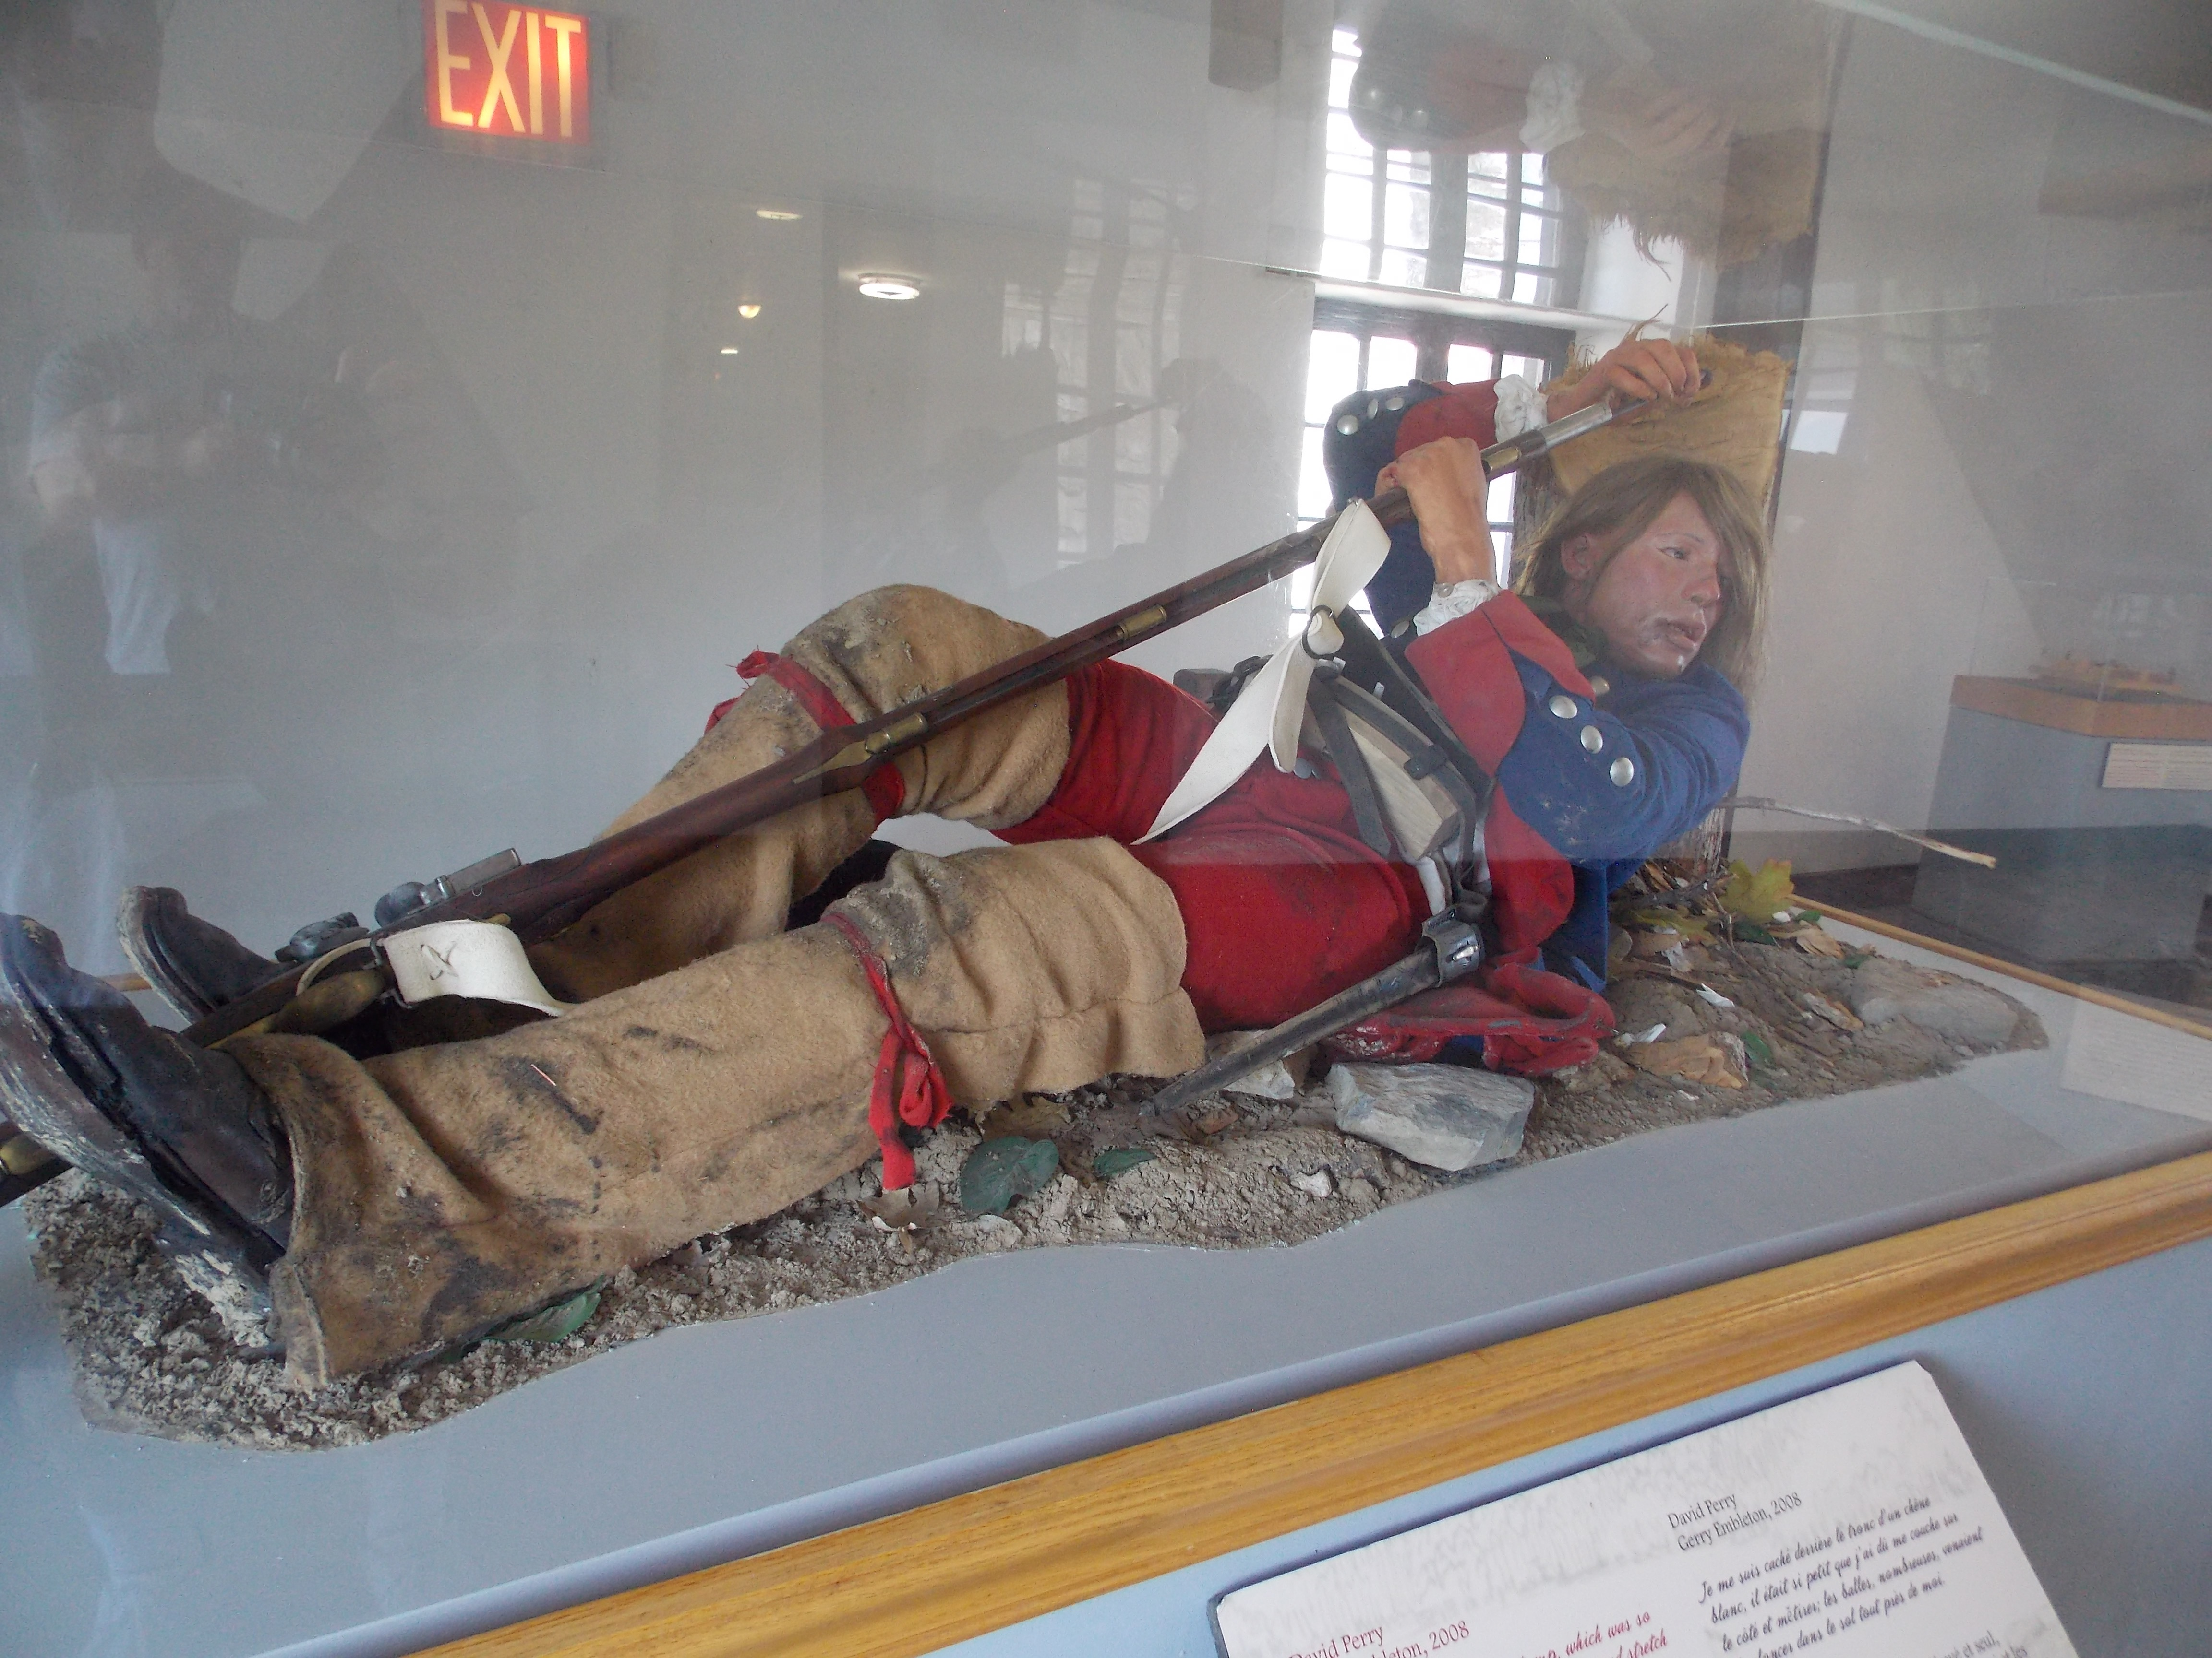
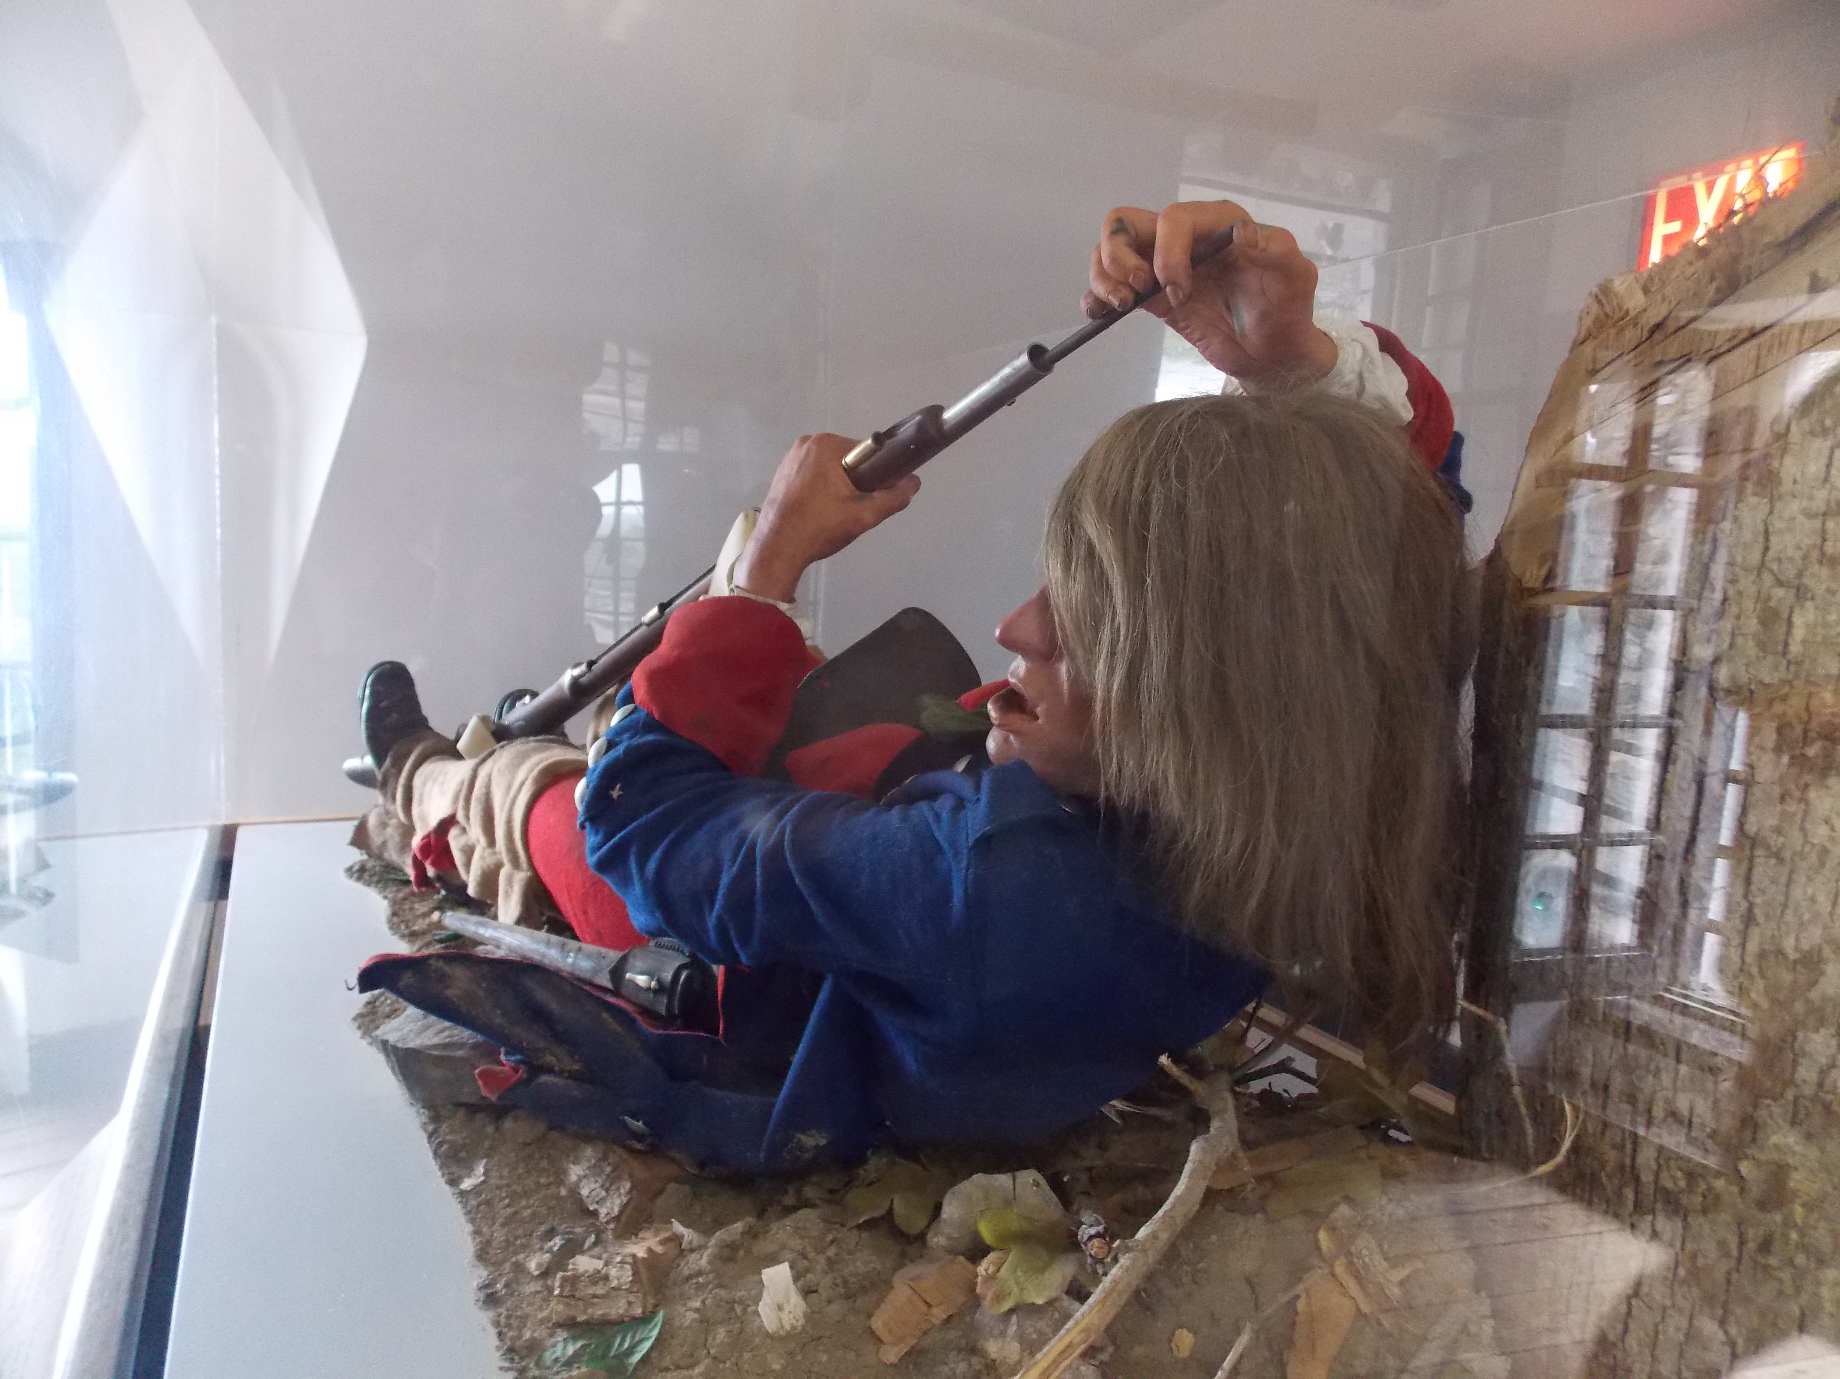
Pg. 3

- Primary source: map of Battle of Carillon from 1758 by Thomas Jeffreys (Library and Archive of Quebec) https://en.wikipedia.org/wiki/Battle_of_Carillon#/media/File:TiconderogaJeffreys1758.jpg
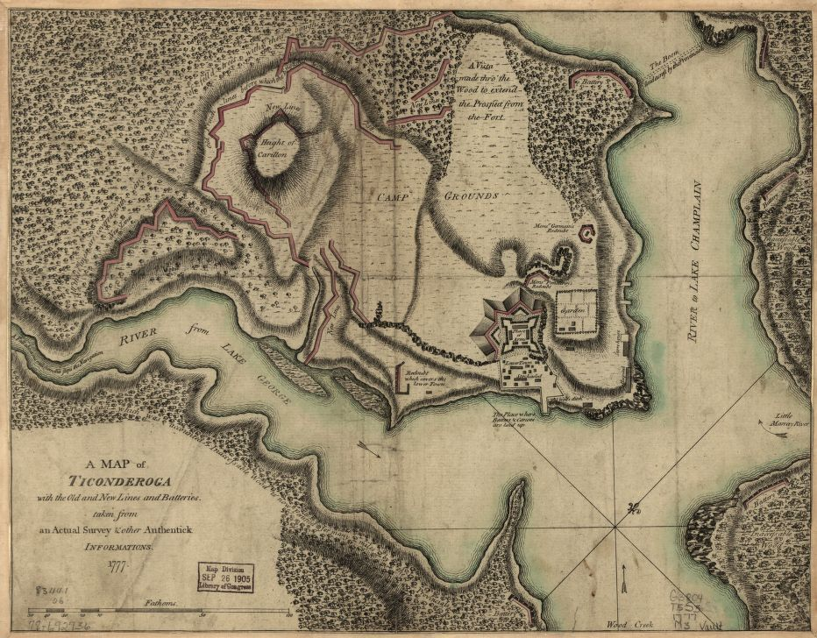

- Schematic (based on map of Battle of Carillon from 1758 by Thomas Jeffreys) https://en.wikipedia.org/wiki/File:CarillonBattle.svg

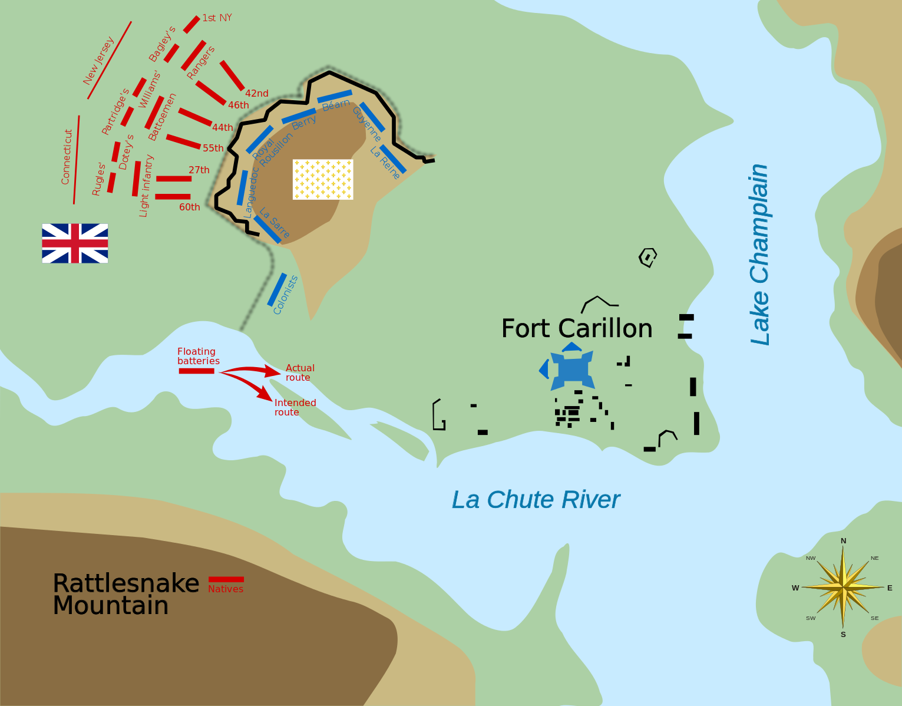

Pg. 4

- Photos from differing points of view

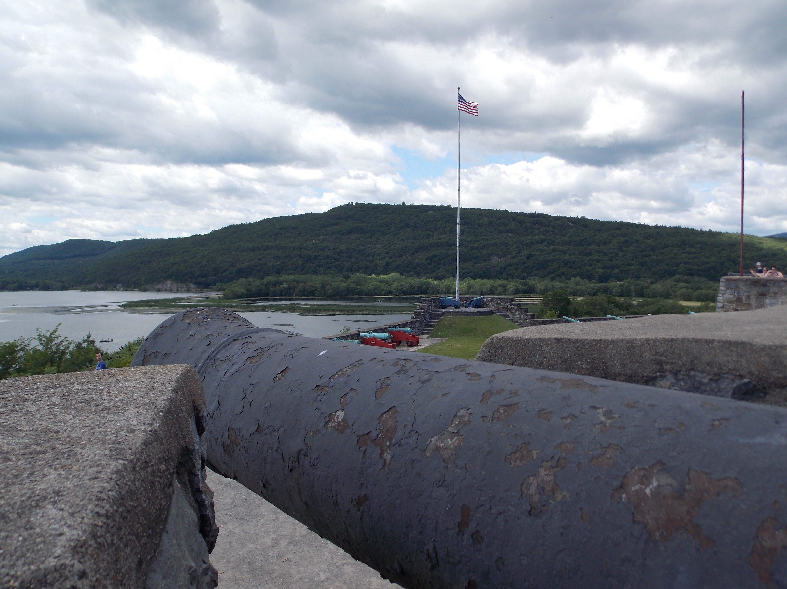
Photo of Mount Defiance and mount of the La Chute River, taken from the fort

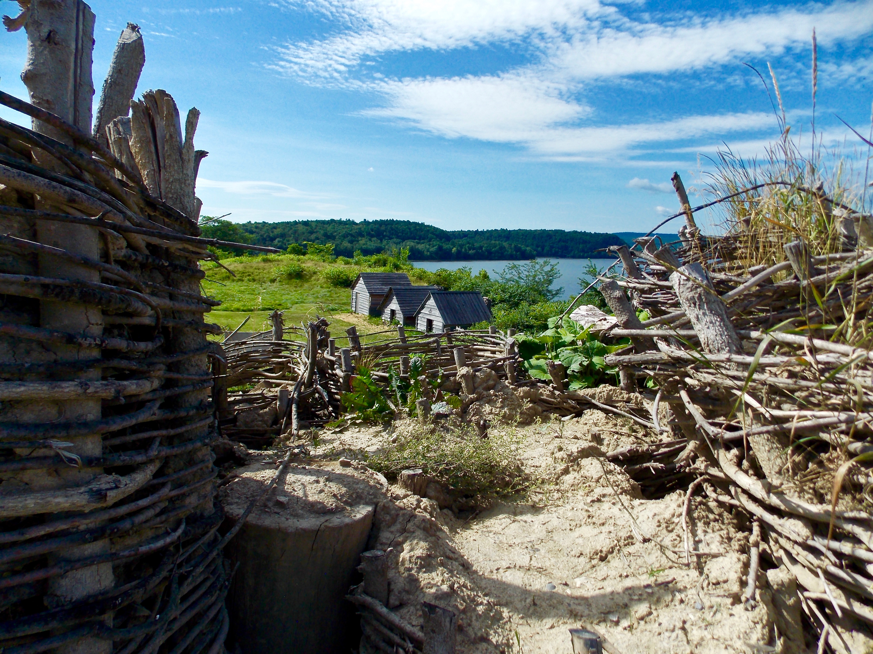
Photo looking east over Lake Champlain, taken from the fort
Pg. 5

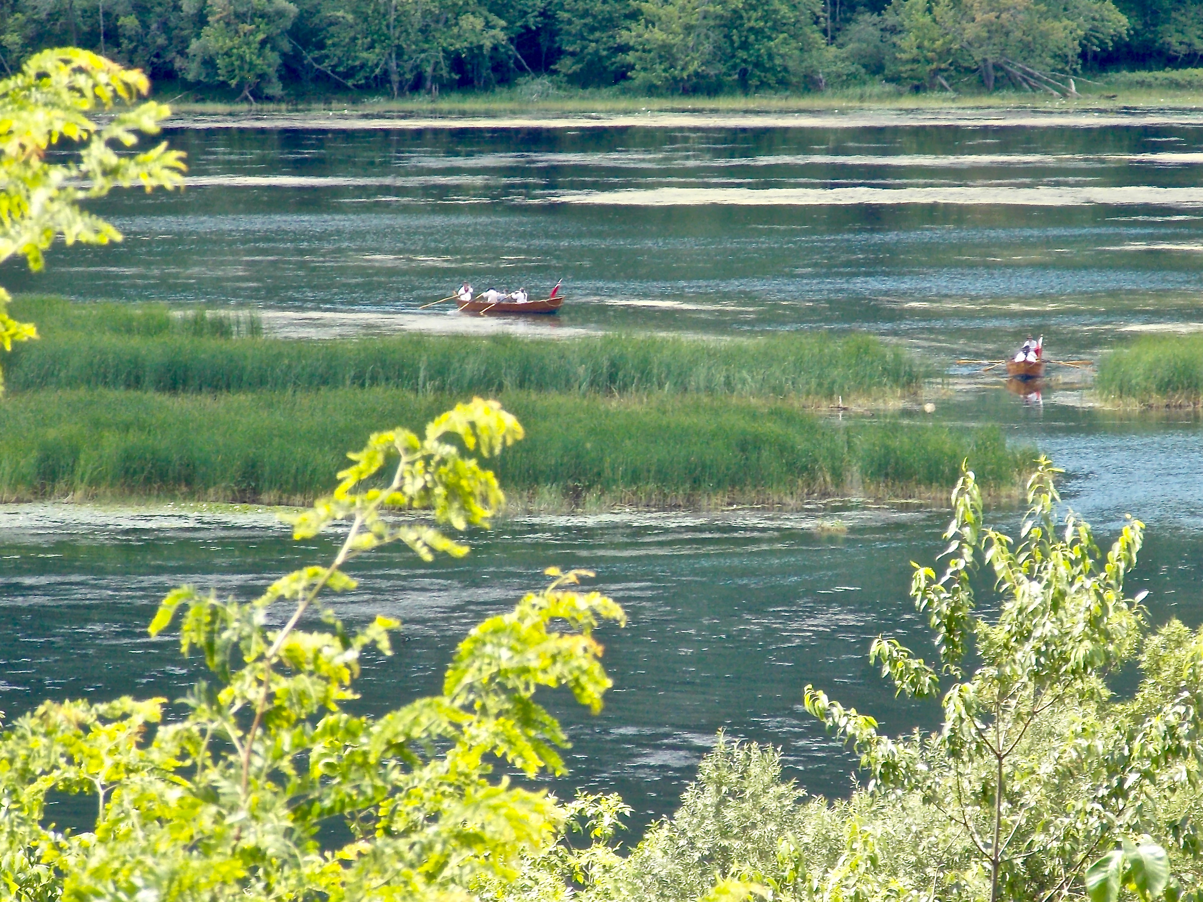
Photo of approaching bateau on the mouth of the La Chute River, taken from the fort

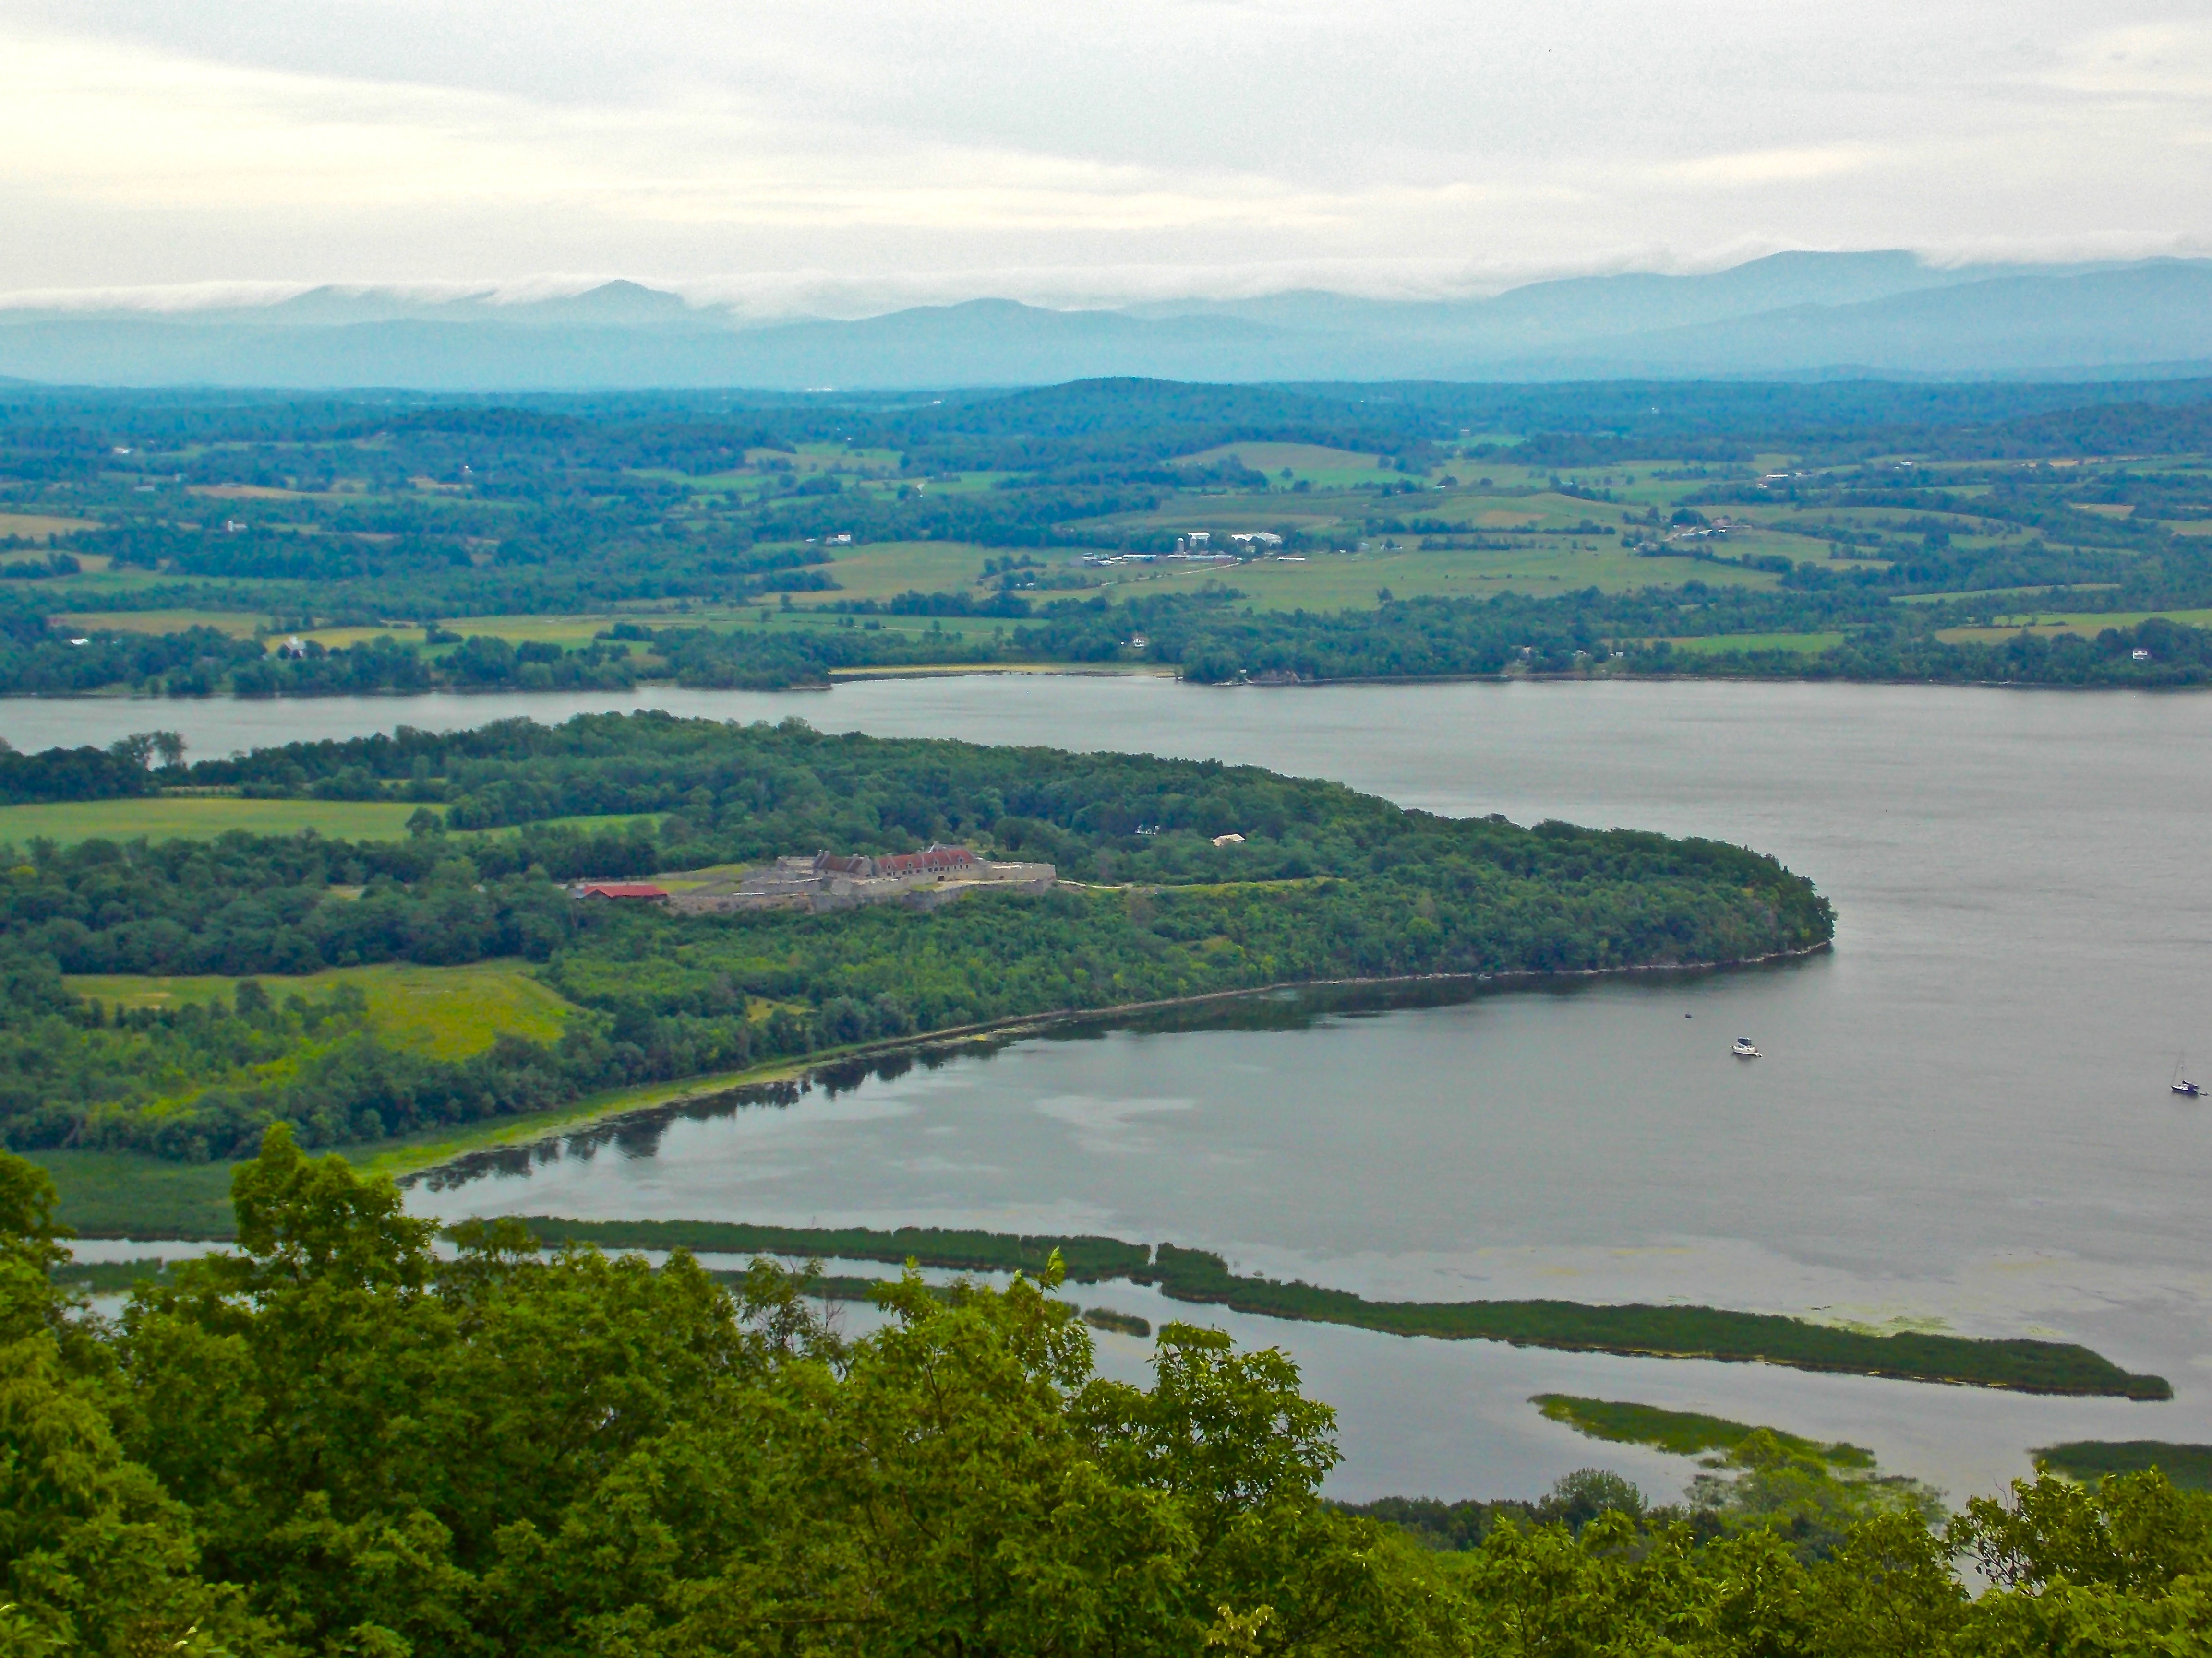
Photo of the fort, the mouth of the La Chute River, and Lake Champlain,
taken from atop Mount Defiance

Pg. 6

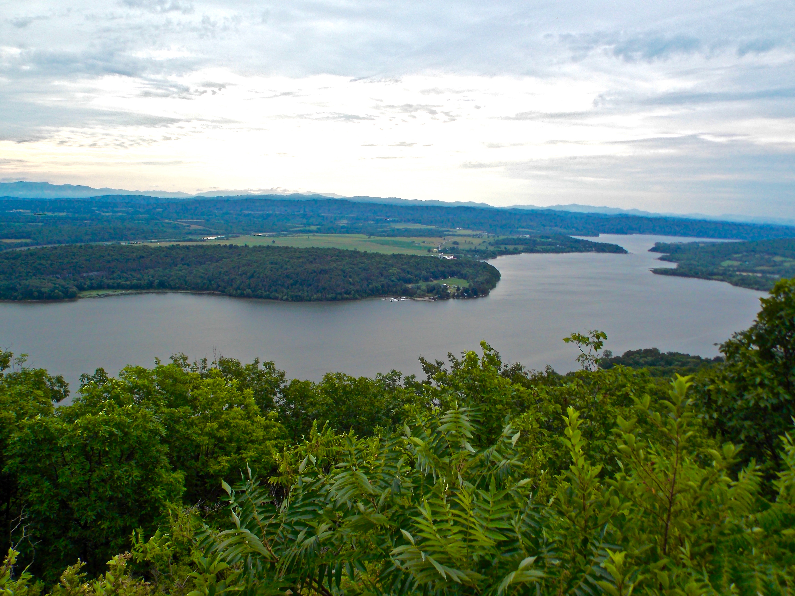
Photo of Lake Champlain, taken from atop Mount Defiance

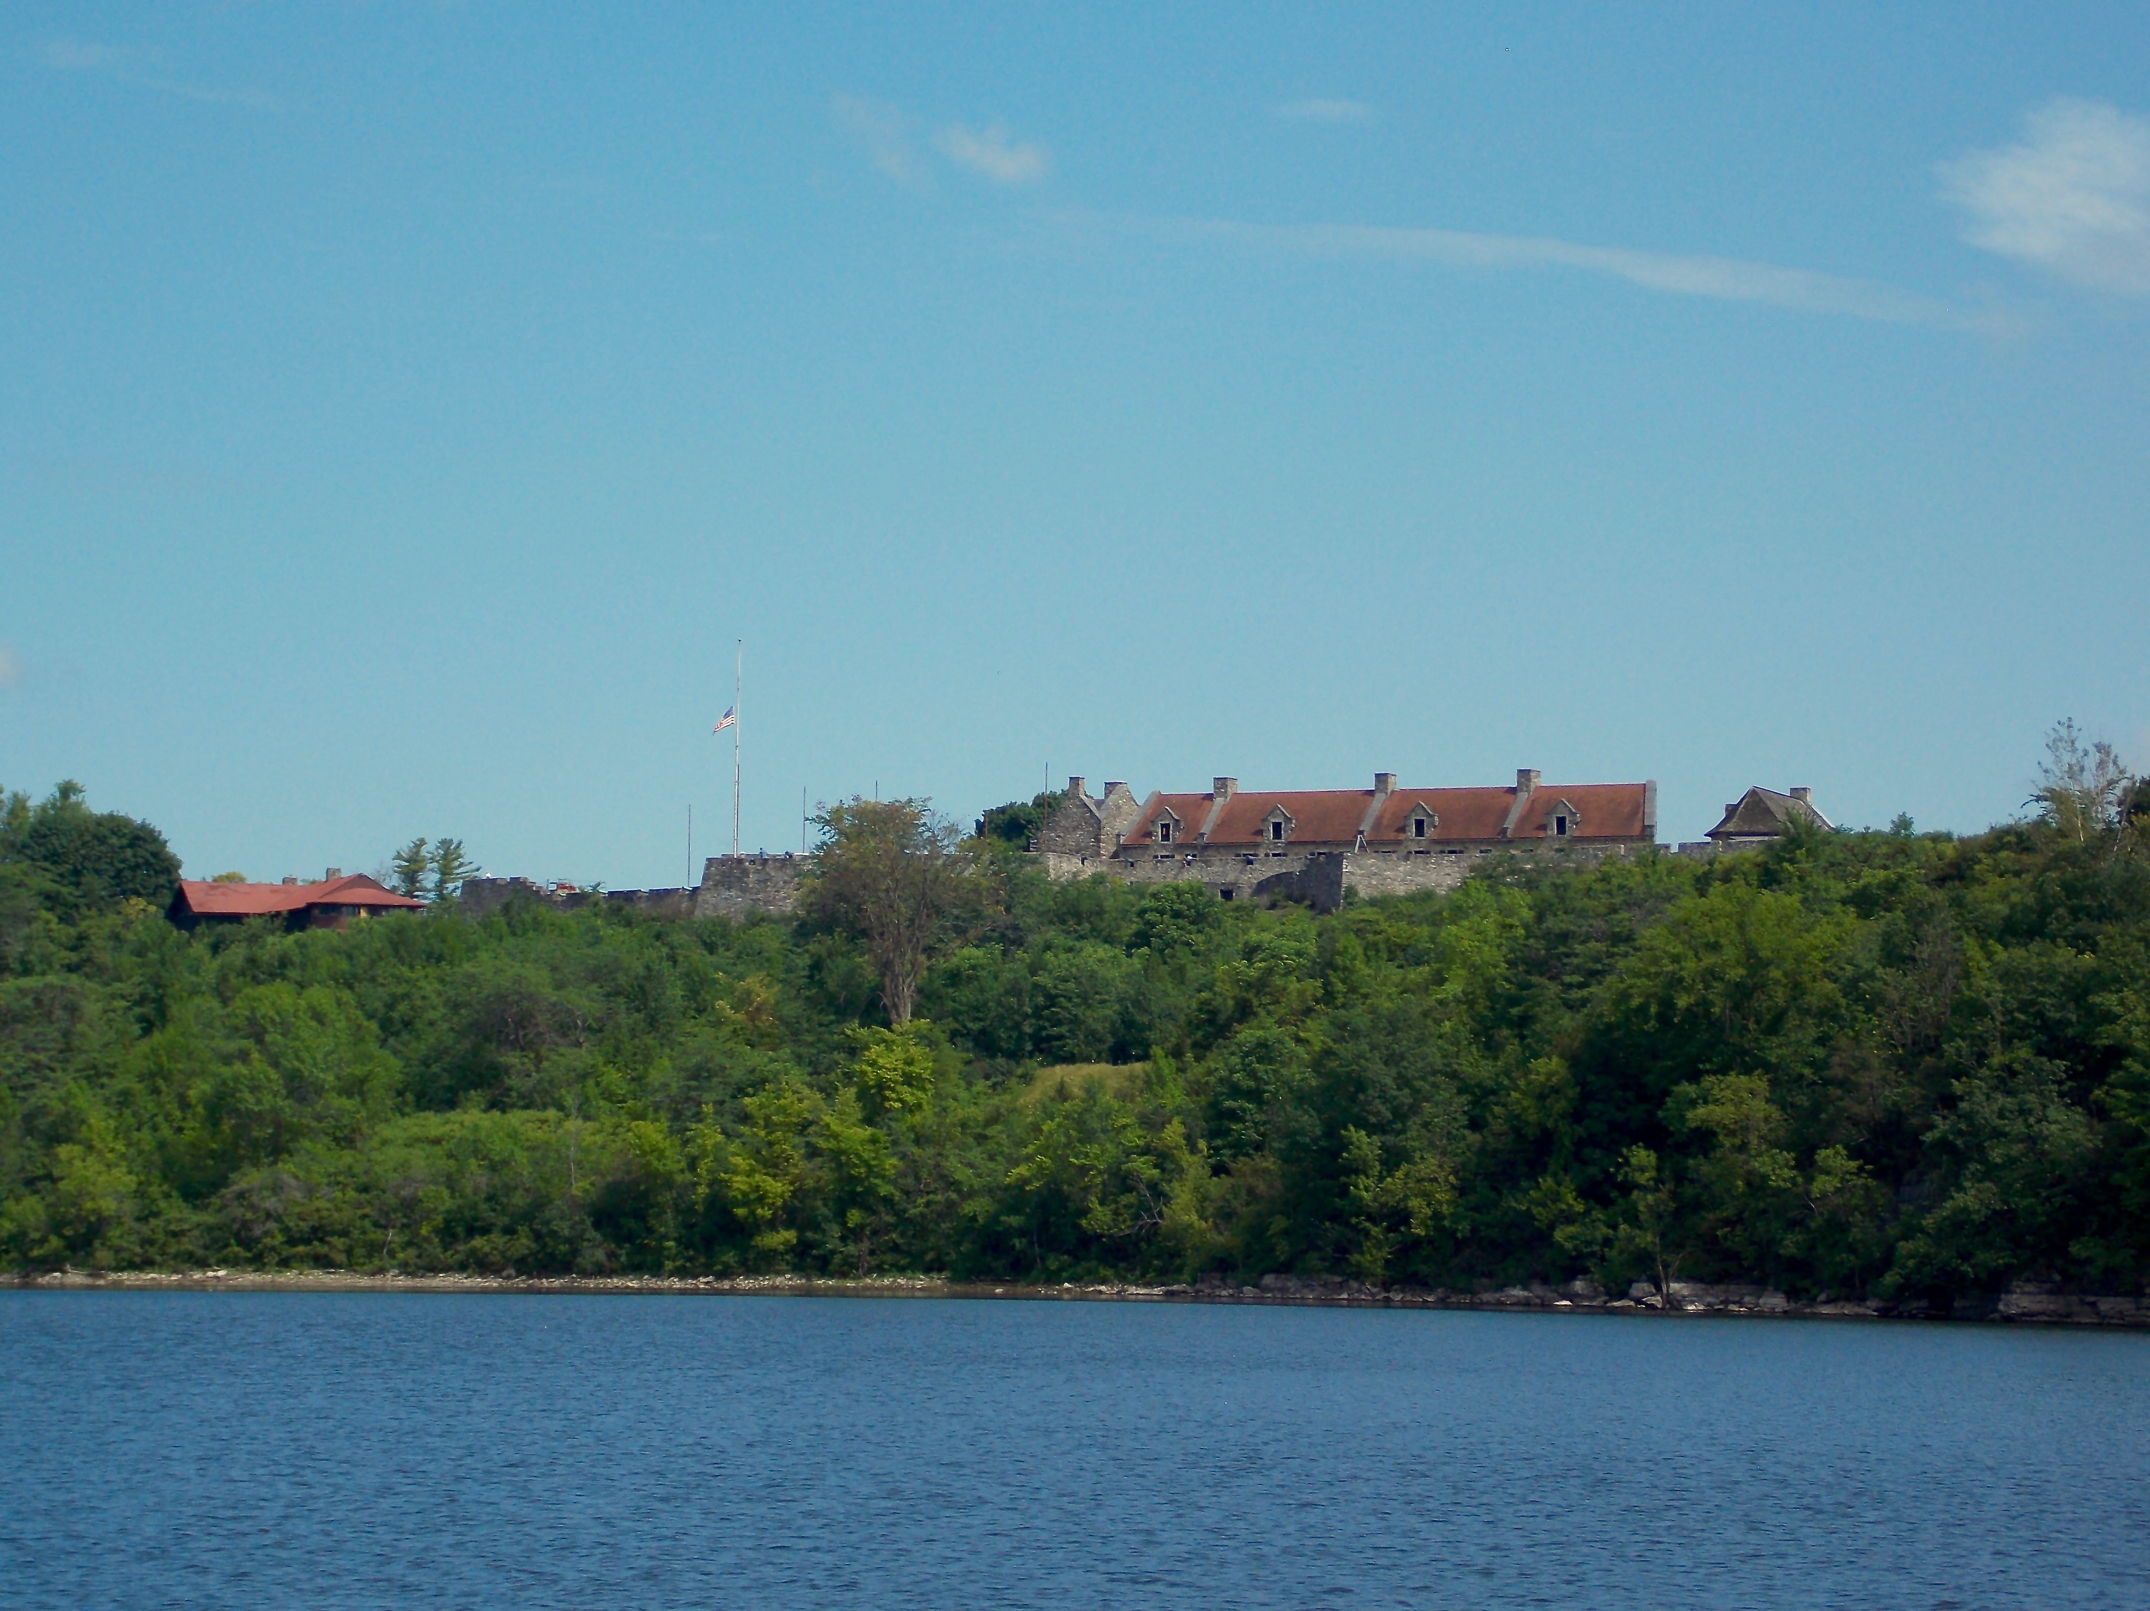
Photo of the fort, taken from Lake Champlain
Pg. 7

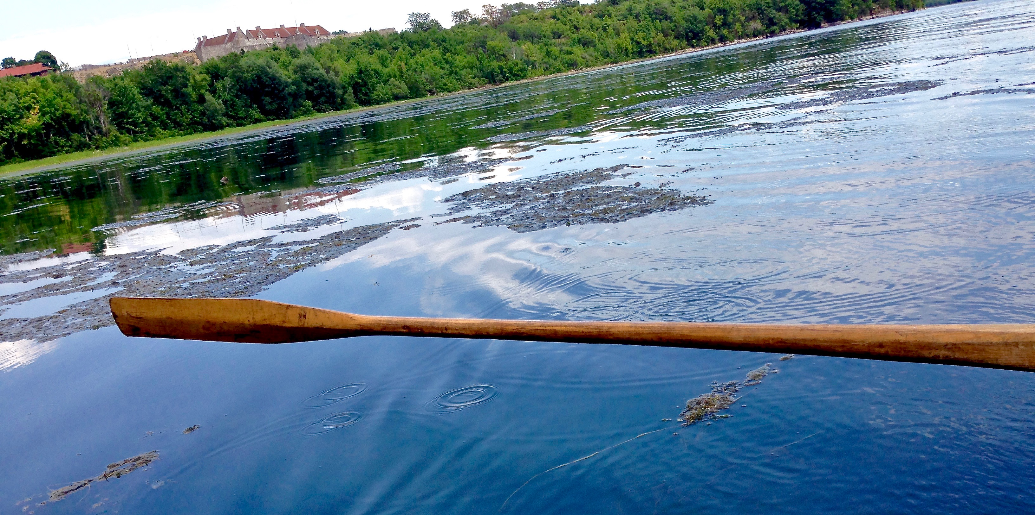
Photo of Fort Ticonderoga, taken from a bateau at the mouth of the La Chute River

- Map of the Heights of Carillon, shared by Nick Spadone at the 2019 Fort Ticonderoga Teacher Institute:

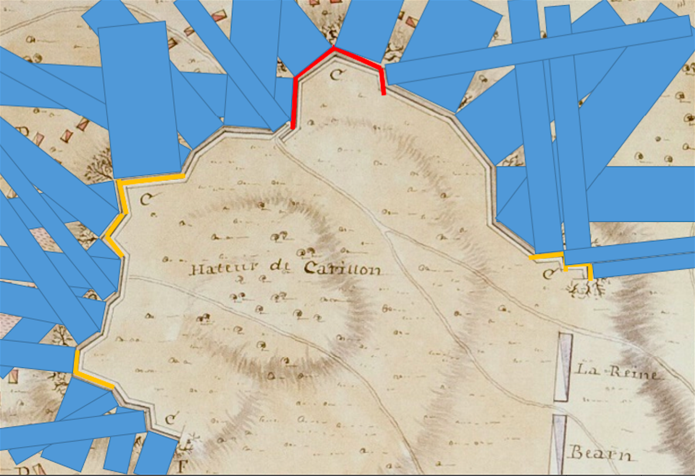

Pg. 8

- Primary source: powder horn (Ticonderoga Collection, Object ID PH-008) and reproduced drawing below (detailed photos at link below) https://fortticonderoga.pastperfectonline.com/webobject/539C3A79-C5C8-4C52-A433-147775715800

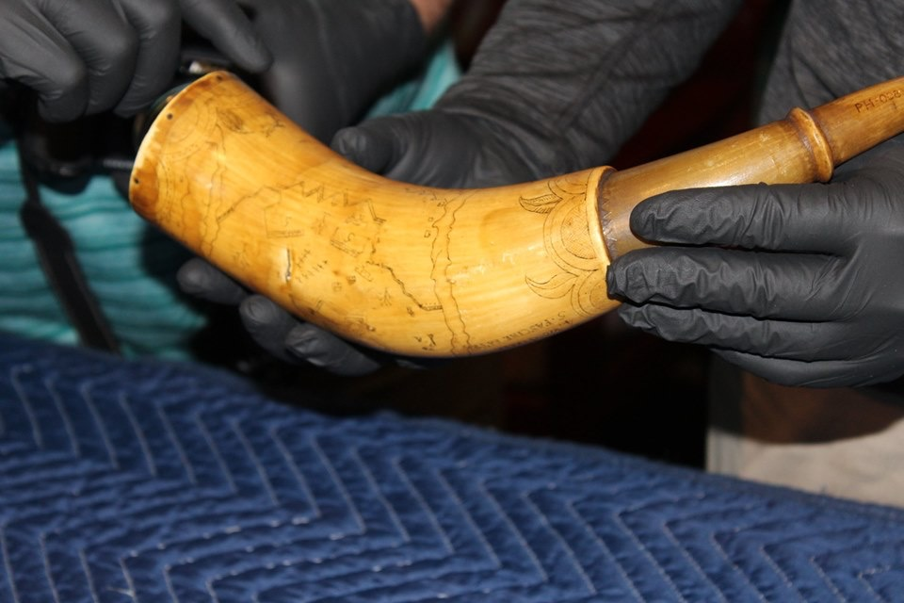
Photo by Wendy Berkelman, 2019 Fort Ticonderoga Teacher Institute Participant

- Flat illustration of Daniel Dwight’s powder horn https://www.fortticonderoga.org/news/daniel-dwights-powder-horn/

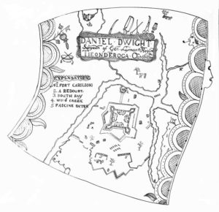
Powder horn illustration from Fort Ticonderoga Curator Blog (December 13, 2013)
Pg. 9

- Powder horn (Ticonderoga Collection, Object ID PH-26) https://fortticonderoga.pastperfectonline.com/webobject/0A441140-A2C7-4BE1-90E5-283498913784

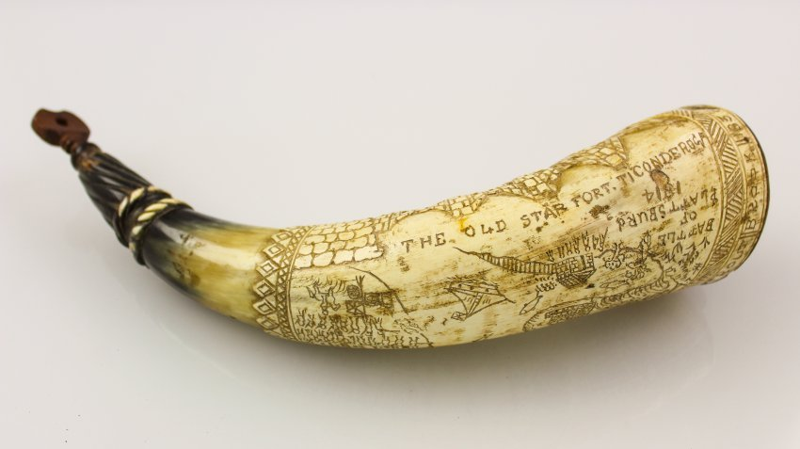
Photo from Fort Ticonderoga Online Collection

- Painting: The Victory of Montcalm’s Troops at Carillon, Early 20th century painting by Henry Alexander Ogden, Fort Ticonderoga collection

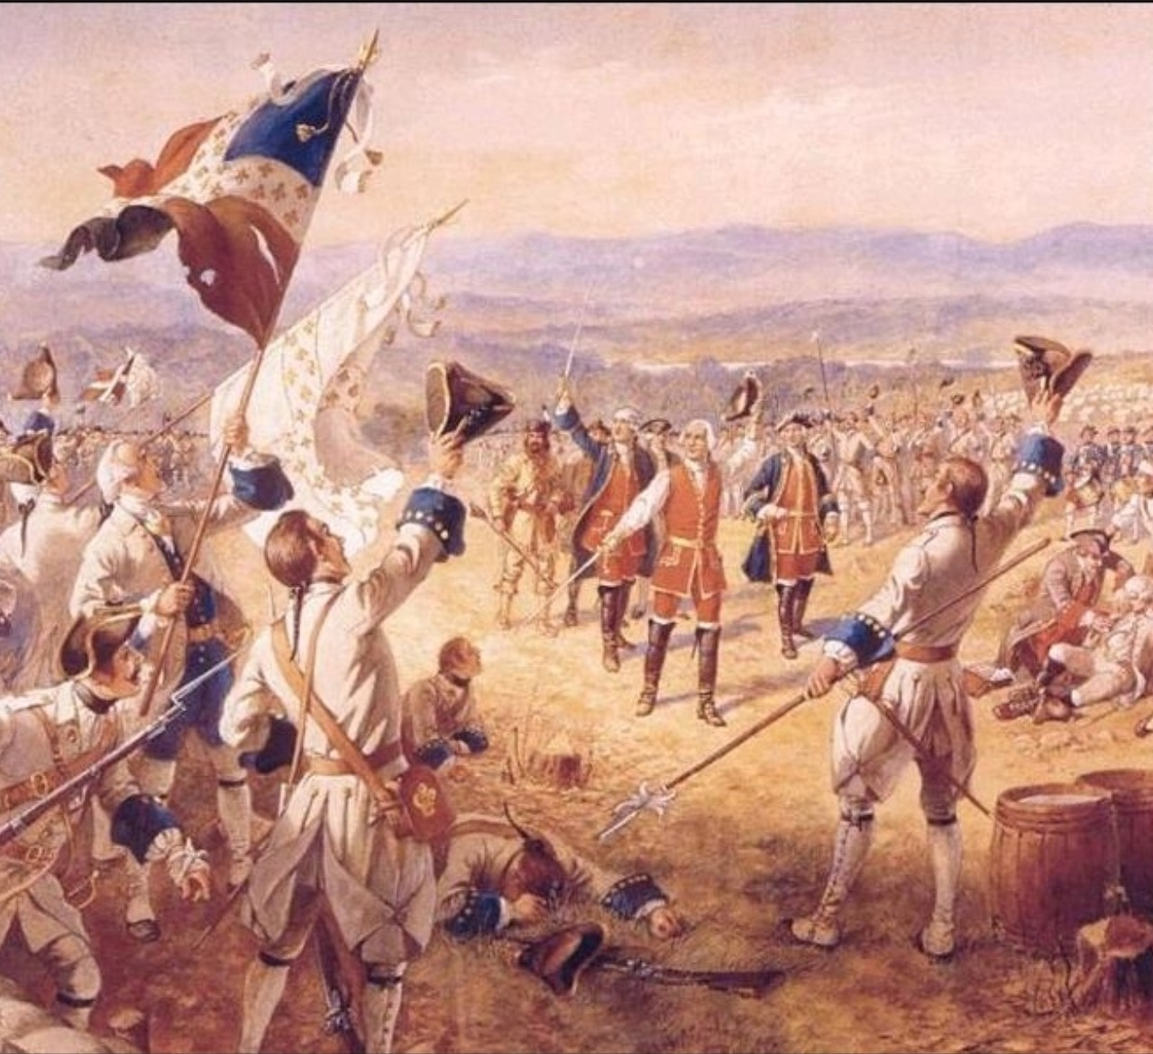
Pg. 10

- Montcalm’s Cross photograph and inscription

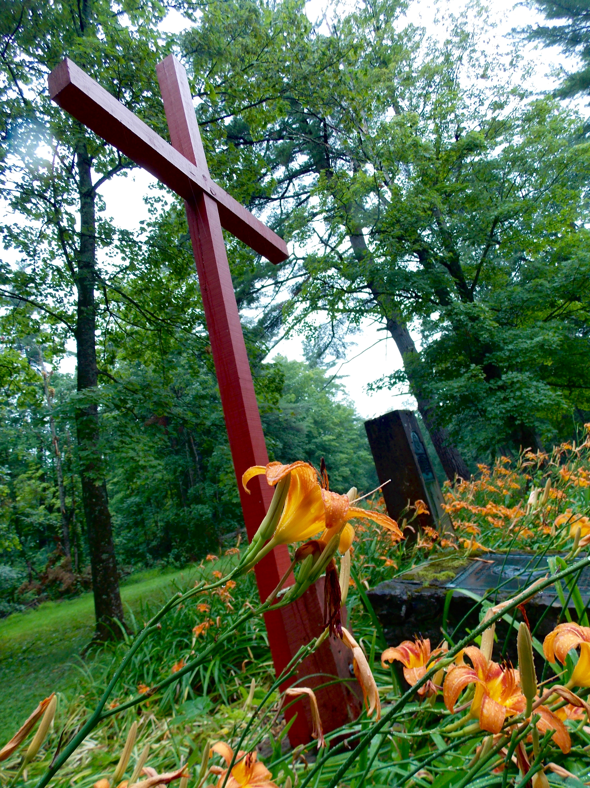
Inscription found in lesson below

Discuss
Use the following questions to guide students into an open discussion to get them thinking about war in general?

- What is war?
- Who fights?
- Who wins?
- Who loses?
- Who is left behind?
- What is it like to fight in a war?

Display the George Washington letter and highlight the quote, “I fortunately escaped without a wound, tho’ the right Wing where I stood was exposed to & received all the Enemy’s fire and was the part where the man was killed & the rest wounded. I can with truth assure you, I heard Bulletts whistle and believe me there was something charming in the sound.”

Ask students and discuss:
- What do you think Washington meant when he wrote that postscript?

Pg. 11

Engage some academic rigor by showing the photos of the David Perry depiction on display at Fort Ticonderoga. Without revealing any information about the model, ask students to notice its details, using the 5 Senses + 1 discussion sheet located at the end of this lesson, and share them in a discussion.

After a while, ask questions to lead them into the primary source, Recollections of an old soldier: The life of Captain David Perry, a Soldier of the French and Revolutionary Wars. Emphasize this quote: “It happened that I got behind a white-oak stump, which was so small that I had to lay on my side, and stretch myself; the balls striking the ground within a hand’s breadth of me every moment, and I could hear the men screaming, and see them dying all around me. I lay there some time. A man could not stand erect, without being hit, any more than he could stand out in a shower, without having drops of rain fall upon him; for the balls came by hands-full.”

Ask:
- Does Perry’s recollection sound different from George Washington’s? How? Why?
- What emotions do these two documents share?
- What emotions seem to be different in the two documents?
- Why do you think Perry agreed to fight in the Battle of Carillon?

Guide
The conditions of battle differ from field to field and time to time. When we learned about the Battle of Jumonville Glenn, we saw that it was an “impromptu” attack on an unsuspecting company of French soldiers by a British group (with Washington leading). In this lesson about the Battle of Carillon, you should note some differences.

Inform students that Perry did not write his memoir until 1819. Ask them:
- Do you think Perry forgot anything in the time since the battle?
- Do you think Perry changed anything (embellished) since the battle? If so, what?

Content
Show students images of the Daniel Dwight powder horn from the Fort Ticonderoga collection and the other powder horn listed in Resources above. Let students try to figure out what a powder horn is used for. Explain.

Pg. 12

Note the dates on the horns are different. The second is listed on the artifact inventory as “anachronistic” and evokes the Battle of Plattsburgh from several years later. The idea here is to prompt students to wonder about the shape of the fort. Some may notice the carving on the second horn says “THE OLD STAR FORT TICONDEROGA”.

Ask:
- How was the fort shaped?
- Why do you think the fort was designed in such a shape?

Find an aerial picture of Fort Ticonderoga online, and continue to lead students to talk about the shape and position of the fort on the peninsula. Discuss the reasons for the position of the fort as a defense against the British army descending Lake George and Lake Champlain. Follow this by showing photos taken from the fort, from Mount Defiance, and from the lake. Direct students to consider the topography of the area and identify difficulties in defending the lake and the land.

Point out the defenses along the western walls, as well – the land side of the fort.
Display images of Fort Ticonderoga and allow students to make observations.

Show the 1758 map of Lake Champlain and Lake George, with the fort in between. Ask students why this might be a strategic location for the fort. Also display the schematic map for a clearer visual interpretation of troop placements. Discuss.

- Help students notice that it has a good view of locations where the enemy may descend the lakes to encroach upon New France.

- Help students understand that cannon may accurately fire upon the enemy vessels descending the lake, as well as from Mount Defiance or along Mount Independence.

Students should notice the defensive positions outside the walls of the fort – specifically on the Heights of Carillon. Ask them why such enforcements might be necessary/strategic. Specifically point out the shape/angles. Ask:

- However, what if the enemy came by land, skirting around to the west of the fort and up through what is now known as the Heights of Carillon?
- What if the British brought 16,000 soldiers to fight against the 3,700 French troops within Fort Carillon?
- Why would General Montcalm send troops outside the protective walls of the fort?

Pg. 13

Teach about the Battle of Fort Carillon in 1757, including information about the fortifications and the abatis at the Heights of Carillon.

Show the British attack on the redoubts at the Heights of Carillon, using video clips from the PBS documentary, The War that Made America, episode 3, in which students should recognize some of David Perry’s words.

Inform students that this was a battle that took all day. It was also the bloodiest, deadliest battle of the war (and in fact would be the deadliest battle until the American Civil War in the 1860s). Montcalm’s men successfully defended their positions in the Heights and on the lakes, and the British General Abercrombie retreated his men, leaving many dead on the battlefield.

Conclude the discussion.

Connect
Use the map shared by Nick Spadone at the 2019 Fort Ticonderoga Teacher Institute. The map shows projected angles of fire from the fortifications at the Heights of Carillon.

Now allow students to make their own angled line of defense using lengths of toothpicks or spaghetti noodles. They will glue the materials to a precut piece of cardboard. Students should indicate which side is the defensive side and which side is the offensive side. Project lines of fire on the cardboard like the Spadone map still displayed and color in.

Students should now see if there are any weak spots in their defensive angles. Ask:
- What difficulties did you experience in designing your defense?

Option: allow another effort in which students now plan to avoid weak spots.

Option: is it possible to use lengths of foam pool noodles to take this STEM activity to another level?

Extend
- Measure angles and lines on worksheets attached.

- Provide the flat powder horn shape sheet to students. Students must carefully sketch their defensive designs on the sheet. Have them add a design for their names to place on the sheet. They may also add other features, using the powder horn images from earlier as examples.
Pg. 14

- Give bananas to students so they can make their own powder horns. Students use toothpicks to scratch their designed onto the bananas’ skins. Their carvings will quickly begin to darken. Be sure to get some photos of their bananas before allowing them to peel and eat.

- Other extension activities/ideas are found on this page of The Hoggatteer Revolution: https://hoggatteer.weebly.com/homeroom/fort-carry-on

Wrap Up
Conclude the lesson by sharing the Ogden painting, The Victory of Montcalm’s Troops at Carillon. Have students share what they notice in the painting and what they wonder about it. Ask:

- Is the painting an accurate portrayal of Montcalm’s success?

Allow students to see the inscription on the cross erected by the Marquis de Montcalm following the Battle of Carillon:

​Chretien! Ce ne fut point Montcalm et la prudence,
Ces arbres renversė, ce hėros, leur exploits,
Qui des Anglais confus ont brisė l'espėrance;
C’est le bras de ton Dieu, vainqueur sur cette croix.
Or, in English:
Christian, behold! Not all the care that Montcalm took,
Nor this fearsome abatis, nor all our heroes' feats
Have stunned the English here, have shattered all their hopes;
​ Instead the arm of God prevailed, the victor of this cross.

Ask:
- Does Montcalm’s inscription change your opinion of the Ogden painting?
- What kind of personal attributes can we identify about the Marquis de Montcalm as a result of this lesson?

Assess
The educator may assess as students progress through the lesson. Please note that this lesson set touches on many objectives/standards, and should be customized to emphasize only a portion of the objectives/standards provided.

Pg. 15

- Stop and ask students to do one-minute writes about what is happening at predetermined points along the lesson.

- Use a scoring guide to assess the 5 Senses + 1 sheet.

- Grade geometry/measurement worksheets as normal.

- Use a scoring guide to assess each student’s application of knowledge as s/he designs the redoubt and identifies weaknesses.

- Administer a final test to determine comprehension of the Battle of Carillon. The teacher may use Socrative, Kahoot!, or another electronic or paper process to administer the final assessment.

Support
The following pages are referenced in the lesson above for student use.

5 SENSES +1

Describe the scene of the Battle of Carillon as if you were there.

SEE

HEAR

SMELL

TOUCH

TASTE

FEEL (EMOTIONALLY)
FORT CARILLON GEOMETRY
Interior Angles

B
A
C
D
E
H
F
I
J
K
L
M
N
O
G

You just measured 15 of Fort Ticonderoga’s interior angles.

How many right angles did you find? __________
These numbers must add up to 15.

How many acute angles did you find? __________

How many obtuse angles did you find? __________
FORT CARILLON GEOMETRY AND MEASUREMENT
Exterior Angles

2
1
3
4
5
7
6

You just measured seven of Fort Ticonderoga’s exterior angles.

How many right angles did you find? __________
These numbers must add up to seven.

How many acute angles did you find? __________

How many obtuse angles did you find? __________
FORT CARILLON GEOMETRY AND MEASUREMENT
Linear Measurement (Rounded to Nearest ¼-inch)
P
Q
R
S
T
U
V

FLAT POWDER HORN DESIGN
LARGE END
SMALL END
TOP
BOTTOM

