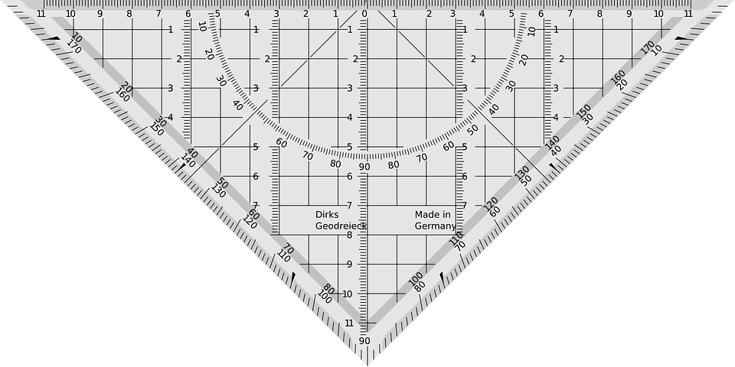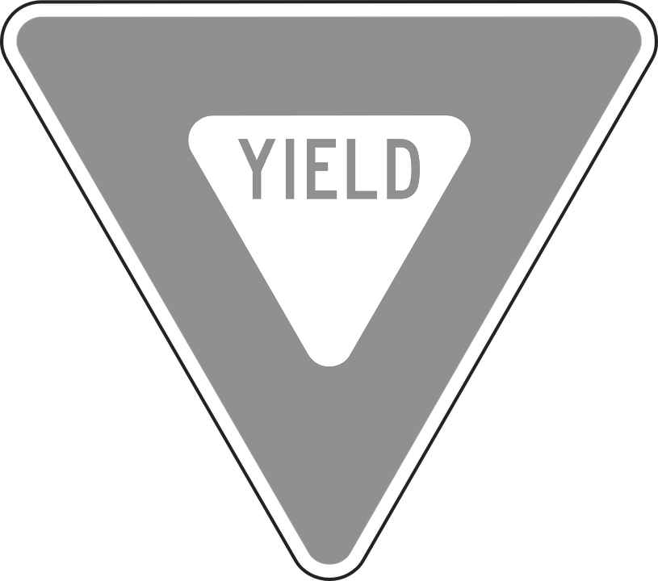

**No Offense**

**We Are Family**

**Measuring Up**

**Play**

*Drama games taken from dramamenu.com and Drama Menu, by Glen Trefor-Jones

**Respect & Focus**

Splat

Heads Up, Heads Down

1 Duck, 2 Legs, Quack!

Concentration Circle

Group Walk

Yes, Let’s!

Yeah, and…

Character Bus

1-10

1-Word Story

*



Dale Hoggatt

Educator, Cecil Floyd Elementary

Joplin, Missouri

hoggatt.weebly.com

hoggatteer.weebly.com

dalehoggatt@joplinschools.org

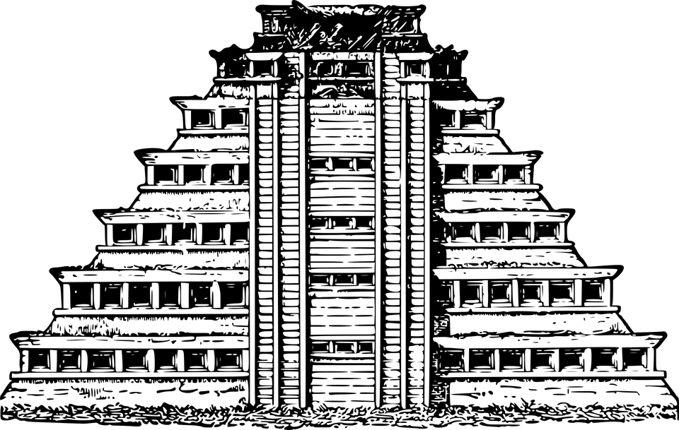

**Building**

**Successful**

**Mistakes**