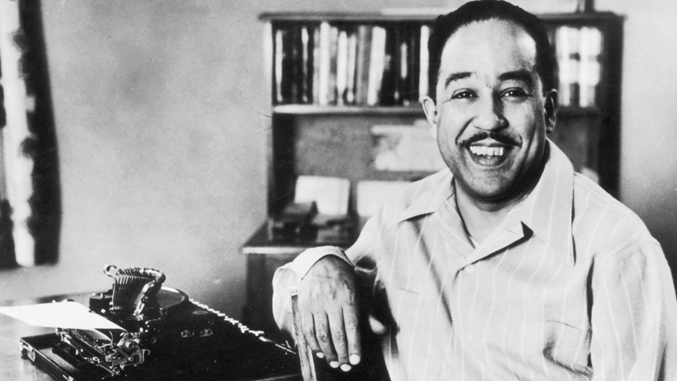
Langston Hughes, the poet laureate of the Harlem Renaissance, lent his voice to the cause of human equality and shone a light on the struggles of being black in the United States during a troubling time.

Hughes was born right here in Joplin, Missouri. His poem – I, Too – is a simple statement that described his social status and the positive outlook he had for his own future and for the future of his race.
I, too, sing America.

I am the darker brother.
They send me to eat in the kitchen
When company comes,
But I laugh,
And eat well,
And grow strong.

Tomorrow,
I’ll be at the table
When company comes,
Nobody’ll dare
Say to me,
“Eat in the kitchen,"
Then.

Besides,
They’ll see how beautiful I am
And be ashamed—

I, too, am America

