Dale Hoggatt

Educator, Cecil Floyd Elementary

Joplin, Missouri

hoggatt.weebly.com

hoggatteer.weebly.com

dalehoggatt@joplinschools.org

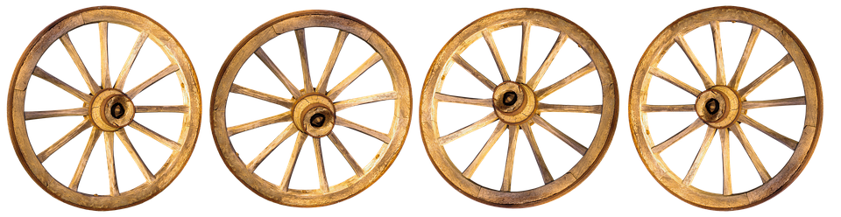



**Counterintuitive**

**Lifeguard**

**Training**

**Mood Music**

**80HD?**

**Music Appreciation**



**There’s No Busyness Like School Busyness, by D. Ed. Hoggatt (available now)**

**Art Appreciation**

**Watch Like a Reader**

**Uniterrupted Classwide Conversations**

**Navigating**

**&**

**Engaging**